**Frontend Assignment:** As an end user, an application needs to be developed where the notes need to be managed. In this assignment, developer is supposed to develop a UI which takes care of followings:

1. We should be able to create a note(title + description).
2. We should be able to manage our created notes.
3. We should be able to update the existing notes.
4. We should be able to delete the existing notes.

Test plan:

1. When I click the ‘Add Note’ button, I should be able to create a new note with title and description. Validation should be taken care, a note can’t be saved without title and description.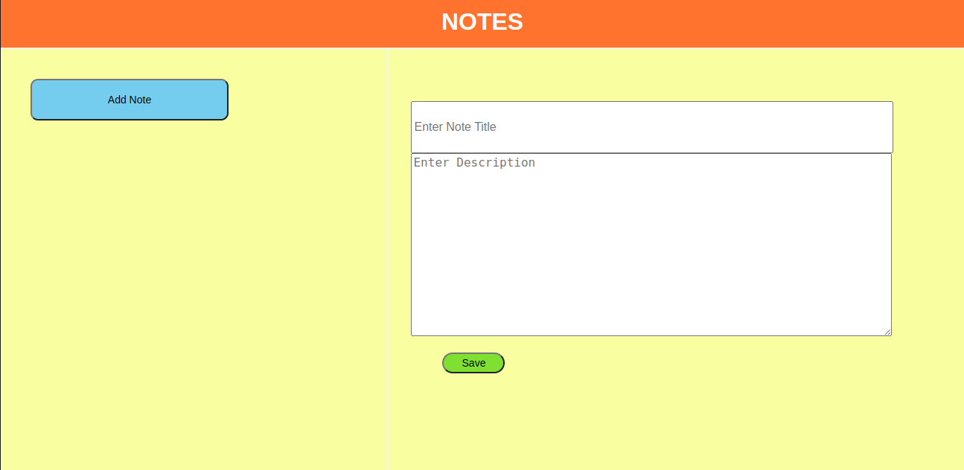
2. When I click the save the button, I should be able to store the note with the title as reference.

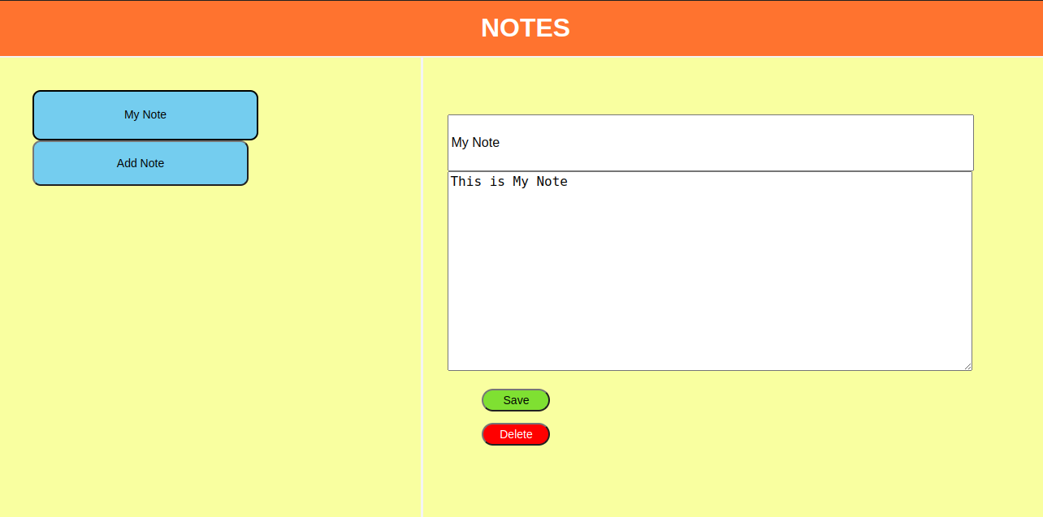

1. At any time, I should be able to delete the existing note.
2. At any time, I should be able to update the existing note(title + description).
3. At any time, I should be able to view the note( title + description).
4. When I reload the page, I shouldn’t lose the notes.(use local storage).
5. When I add multiple notes beyond the current page limit, implement page scrollable for the title references.
6. UI should not be the same with the referenced image, come up with your own idea.